**Name:** Muhammad Fahad

**ID:** FA19-BSSE-0014

**Course:** Data Communications and Networks

**Section:** AM

**Teacher:** SYED MEIRAJ Hasan

### Task 01:

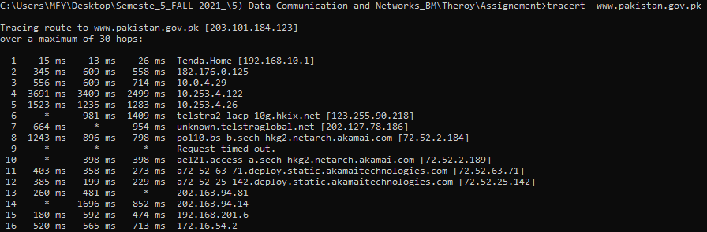

### Task 02 ([www.nadra.gov.pk](http://www.nadra.gov.pk)):

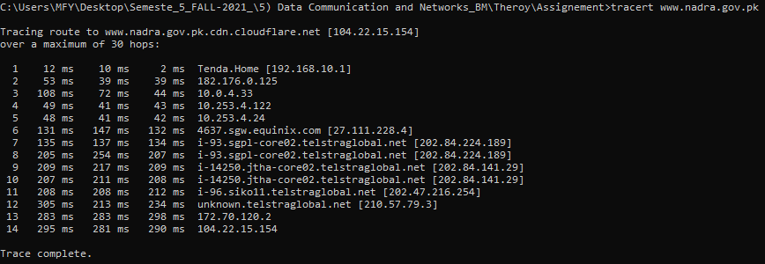

### Task 03 (www.finance.gov.pk):

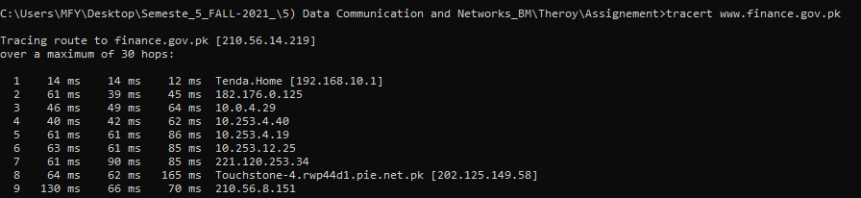

### Task 04 ([www.pmo.gov.pk](http://www.pmo.gov.pk)):

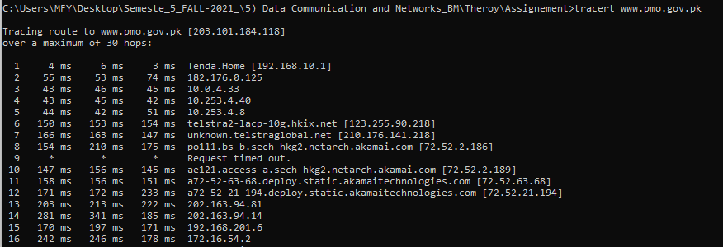

### Task 05 ([www.uet.edu.pk](http://www.uet.edu.pk)):

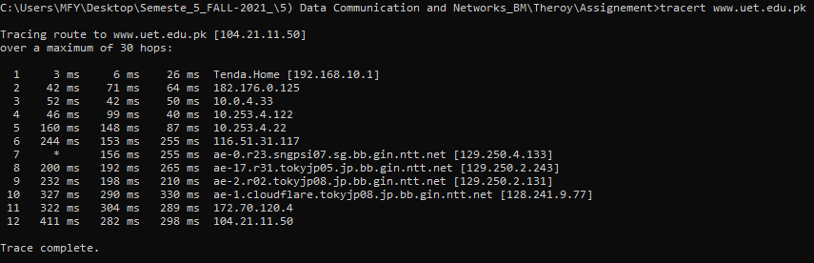

### Task 06 ([www.uswat.edu.pk](http://www.uswat.edu.pk)):

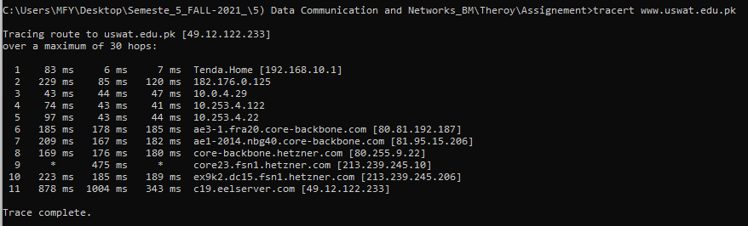

### Task 07 ([www.kum.edu.pk](http://www.kum.edu.pk)):

